ServiceNow Employee Portal User Guide
How to Submit, Track, and Manage IT Support Tickets
Document ID: | UG-SNOW-2026-V1 | Last Updated: | July 2026
Target Audience: | All Enterprise Staff | Portal Access: | Single Sign-On (SSO)

1. Overview & Accessing the Portal
The ServiceNow Employee Service Portal is your centralized self-service platform for reporting technical faults, ordering IT equipment, requesting software access, and tracking existing support tickets.
1.1 Log In via Single Sign-On (SSO)
1. Open any supported web browser (Chrome, Edge, or Safari).
2. Navigate to the corporate portal URL: https://service.corporate.domain
3. The portal uses Single Sign-On (SSO). If prompted, authenticate using your enterprise email address and Multi-Factor Authentication (MFA).
1.2 Navigating the Portal Home Page
Once logged in, the home dashboard provides four main quick-access options:
• Report an Issue: Submit an Incident ticket when something is broken or malfunctioning.
• Request Something: Submit a Service Request for new hardware, software licenses, or access rights.
• Knowledge Base: Search for self-help articles, FAQs, and troubleshooting step-by-step guides.
• My Tickets: View real-time status updates and activity streams for all your submitted tickets.
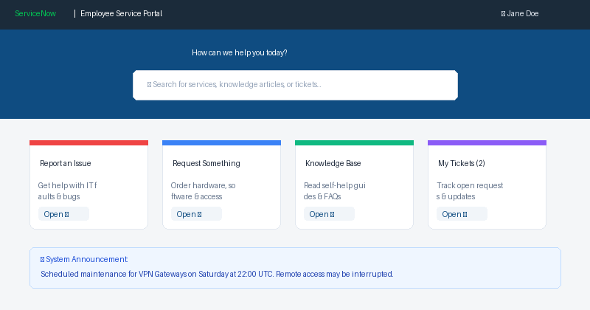
Figure: ServiceNow Employee Service Portal Home Interface
[SEARCH TIP] You can use the central search bar on the portal home page to search across both Knowledge Base articles and Service Catalog forms simultaneously.

2. How to Submit a Support Ticket
Follow the steps below to report an IT fault or hardware/software malfunction to the IT Service Desk.
2.1 Step-by-Step Ticket Submission
1. Click on 'Report an Issue' from the Home page or navigate to Service Catalog > IT Support.
2. Select the appropriate Category (e.g., Hardware, Software, Network/VPN, Email/Access).
3. Fill out the mandatory form fields (marked with a red asterisk *):
• Urgency: Select 'Low', 'Medium', or 'High' based on business impact.
• Short Description: Provide a concise summary of the issue (e.g., 'Laptop screen flickering continuously').
• Detailed Description: Include specific error codes, troubleshooting steps already taken, and location.
4. Attach Files (Optional but Recommended): Click 'Attach File' or drag & drop screenshots/error logs.
5. Click 'Submit Ticket'. A unique Ticket Number (e.g., INC0049201) will be generated immediately.
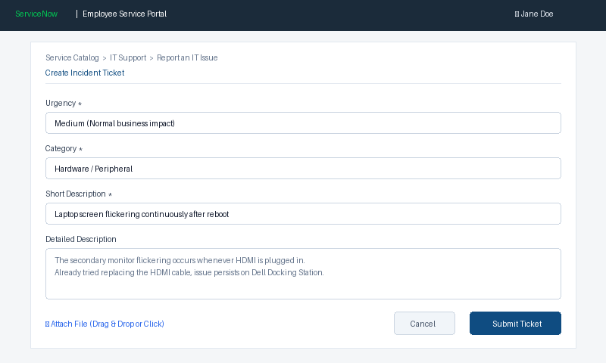
Figure: ServiceNow Incident Ticket Creation Form
[HIGH PRIORITY ESCALATION] For urgent, critical outages affecting entire departments or production servers, do not rely solely on self-service tickets. Call the IT Emergency Hotline directly after submitting.

3. How to View, Track, and Update Tickets
After submitting a ticket, you can monitor its progress, communicate directly with the assigned technician, and upload additional information.
3.1 Accessing 'My Tickets'
1. From the Portal top menu or home page, click 'My Tickets'.
2. Your active tickets will be listed with their current status (e.g., New, In Progress, On Hold, Resolved).
3. Click on any ticket row to open the Detailed Ticket View & Activity Stream.
3.2 Communicating with the IT Support Team
• Activity Stream: Shows all historical updates, timestamps, assigned IT agents, and system comments.
• Adding Comments: Type your message in the 'Type a message' box and click 'Post Update'. The assigned technician will automatically receive an email notification.
• Uploading Attachments: Use the 'Attach File' button to attach new screenshots or requested diagnostic logs.
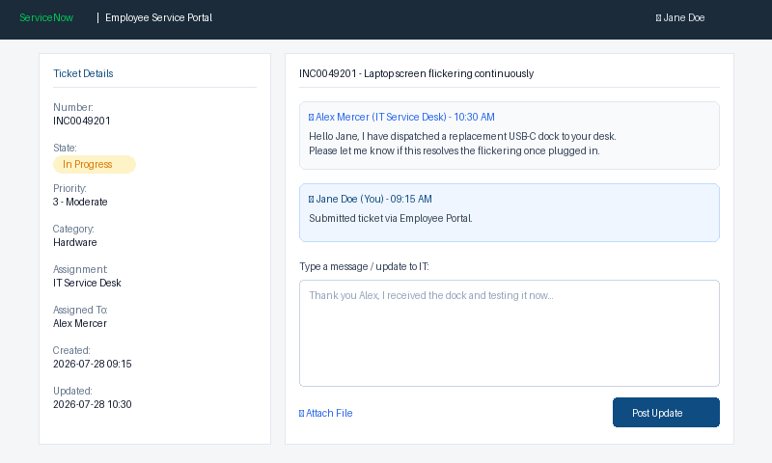
Figure: Ticket Details View and Activity Stream Communication
4. Understanding Ticket States & Resolution
The table below details the lifecycle states of your ServiceNow ticket:
Ticket State | What it Means | Expected User Action
New | Ticket submitted and queued in IT Service Desk dispatcher inbox. | None. Awaiting IT agent assignment.
In Progress | An IT technician has been assigned and is actively investigating. | Monitor Activity Stream for technician questions.
On Hold | Ticket paused (e.g., Awaiting User Info or Vendor Hardware Replacement). | If 'Awaiting User Info', reply in Activity Stream promptly.
Resolved | IT technician has implemented a solution and marked issue fixed. | Verify fix. Click 'Accept' or 'Reopen' within 5 days.
Closed | Ticket permanently finalized. No further changes can be made. | If issue recurs after Closure, submit a new ticket.

5. IT Helpdesk Contact & Support Channels
If you require further assistance or cannot access the ServiceNow Portal, contact the IT Service Desk via the alternative channels below:
• IT Service Portal: https://service.corporate.domain
• IT Service Desk Email: itsupport@corporate.domain (Auto-creates ticket)
• IT Helpdesk Phone: Ext. 4357 (HELP) | Direct: +1 (800) 555-0199
• Support Hours: Standard: Mon - Fri, 08:00 - 18:00 EST | Critical On-Call: 24/7

